The Pennsylvania State University
College of Nursing
Sustainability Council
1/18/2021
Zoom, 12 noon – 1:30 pm

Present: Darlene Clark, Erin Kitt-Lewis, Erica Husser, Janet Knott, Marianne Adam, and Barbara Deffenbaugh

Absent: Elise Krikorian, Caitlyn Albarran, Julia Flaim, Sarah Mattern, Karin Chisom, Jill Arnold, Shannon Choate, Jeremy Hoffman, Whitney Nevins, Brenda Holtzer, Kristal Hockenberry and Kelly Snyder
Staff:

AGENDA ITEM | DISCUSSION/REPORTS/UPDATES | ACTION  PERSON/S RESPONSIBLE  Expected Re-Evaluation  or Completion Date
Old Business | A moment of silence was held to honor Martin Luther King Jrs lasting contributions.
CON Sustainability Council website | Morgann McAfee updated the CON Sustainability Councils website. We will keep the website as a monthly agenda item as a reminder to work on more frequent update submissions. The link is not easily found on the CON website. | Darlene
N325 update | N325: Health and Environmental Sustainability. 25 students enrolled. Brenda is working on assigned readings as the current textbook is a bit lacking | Marianne reported
NLN Education Summit | Erin submitted an abstract to NLN highlighting Sustainable Healthcare Education in an Undergraduate Nursing Program. Marianne, Emily, Kelly and Erin are listed as authors. Others who wish to be involved will be added if the submission is accepted. Erin should be notified in March. | Erin
Video of SDG inclusion in core nursing courses | Video content highlighting “how” to include SDGs in the nursing curriculum is complete. Darlene, Erin and Erica will schedule a videotaping/voice over pp/or zoom recording in February. | Darlene, Erin and Erica  Morgann McAfee and Brook(communications team) will assist with video production
Campus reports | - All is quiet at the moment at the New Kensington campus  - Marianne Adam is a member of the Sustainability Council at the Schuylkill campus  - Nothing new to report at University Park | Janet  Marianne  Darlene, Erica and Barbara
Monash University, Melbourne, Australia | - Erin is working with Kelly and Emily to finalize the letter to the Dean seeking approval for IRB submission of the survey project. The letter is in Teams under Hackathon. The letter will be sent to the Dean in the near future. | Erin, Emily Olivier(junior nursing student), Kelly Snyder(sophomore nursing student)
ECHO project | - the ECHO(Extension for Community Health Outcomes) project is rescheduled for February 24, 2021 at noon via zoom titled Climate Adaptation for Older Adults will be presented by Ruth McDermott-Levy. A Save the Date update was sent to the Sustainability Institute for distribution. Registration is required. Erica will send the updated announcement to the Council. Darlene will forward the registration information separately to Sarah Bronson at the College of Medicine. She is a Sustainability Institute Council member and received the Institute announcement but may pay closer attention with an individual invite. | Erica and Darlene
Citizen Science RWJF | - Erica contacted Leah Buck at the U of Iowa about the Citizen Science Program. RWJF has funding to support Citizen Science projects. Information pertaining to this exchange is located at the end of the January minutes. | Erica
New Business
Studio for Sustainability and Social Action | Erica provided a link to the Studio for Sustainability and Social Action(through Landscape Architecture Dept):  https://sites.psu.edu/sovas3a/symposium-and-exhibition.  https://arts.psu.edu/research/s3a/  Erica was unable to submit a proposal for the symposium, but the Council will keep it on our radar for 2022. | Erica
1-2 credit SDG course offerings | The Sustainability Council will explore 1-2 credit course offerings focusing on SDGs in nursing, particularly SDG 5, 10, 11 and 16 once CCNE accreditation finishes. We need to ascertain whether these credits would benefit students(anyone if it is an interdomain course). | Sustainability Council members
Good Health and Well Being, SDG 3 | Janet initiated a discussion on how the CON might engage faculty and students in a healthy challenge in the fall similar to the program that Melissa Snyder implemented as a step challenge through ANA(Healthy Nurse/Healthy Nation) a few years ago. A fruitful discussion ensued about how we might accomplish this. Healthy People: Healing the Planet could be a theme as we are currently challenged with a vindictive/confrontational environment as well as COVID---if we can shift to a supportive/healing environment as we begin the fall semester, we could collectively heal our own wounds as well as the environment. We could partner with the Student Farm at PSU(outdoor planting/harvesting/weeding activities), the College of Engineering(developing an app), Carter Hunt(HHD professor who teaches a Minor in Sustainability and utilizes a capstone project), RPTM(exercise), BBH(healthy habits), Nutrition(food), College of Medicine(COVID vaccines as a sustainable SDG 3 endeavor) as well as the Crossover Climate faculty. Developing an app or utilizing Penn State Go with an app on that platform could be one way to disseminate the challenge. Participants could then be tracked possibly with a visual map of each of the campuses and their activities as a competitive motivator. Every campus could be involved with incentives for participation and perhaps prizes for a winning campus/college. A 5 minute(all at the same time) break from work/school could be set up for all to go outdoors, reflect on nature in their surroundings, meditate, etc. Engineering students from Drexel set up a system to vaccinate 1200 people/day in Philadelphia(a sustainable action which could be replicated). Research funding could potentially occur(pre and post participation as an example) with funding from the PA Rural Health(Lisa Davis) or the RWJF. | Janet
Smeal College of Business Speaking Engagement | Erik Foley approached Darlene about teaching in a May workshop with the VA system as participants. Their focus is on supply chain management/logistics. Erik is looking for a nurse to discuss how VA managers can better focus their purchases in a sustainable manner. Erik was provided with a contact at Van Zandt VA Medical Center in Altoona as they have earned a Greenhealth Award for the past 8 years or so. His name is Glenn Holsinger. | Darlene
Annual Sustainability Showcase Summary | 12 Council Chairs and 7 Commonwealth Chairs shared a 2 minute summary of their Sustainability Activities for 2020. It was well received. There are many diverse initiatives occurring throughout the university community statewide. | Darlene, Marianne, Erin, Brenda, Erica attended
Climate Crossover meeting | Erin met with Dr. Sharma(HHD) and Mark Sentesy(LA) about HHD/CON collaboration as Dr. Sharma is new to Climate Crossover. The meeting was cut short and will be rescheduled but they did discuss an open work group gathering when they meet next. | Erin
Adjourn | Meeting ended 1:30 pm
Next Meeting | Monday, February 15, 12 –1 :30 pm. Sustainability Council will continue to meet the third Monday of each month using a recurring zoom address.  Zoom: 98035519444  Password: 487784 | Darlene
Submitted by: Darlene Clark
** An RWJF newsletter is the first place that I saw the term “citizen science” when they described an investigator that they funded (see nice process paper here) https://www.ncbi.nlm.nih.gov/pmc/articles/PMC6687391/. Since that time the U.S. gov passed 15 USC 3724: Crowdsourcing and citizen science (see here) https://uscode.house.gov/view.xhtml?req=granuleid:USC-prelim-title15-section3724)&num=0&edition=prelim and https://www.citizenscience.gov/about/#. In some ways the big NIH “All of Us” initiative is sort of a citizen science project (with Big Brother as your partner) https://allofus.nih.gov/. My personal favorite citizen scientist project is the Annual Christmas Bird Count https://www.audubon.org/conservation/join-christmas-bird-count. If you look at all of these resources you will get a general idea of what is meant by the term.
We are not doing anything YET that I am aware of it. However, I’m writing an internal grant to get some $$ and may do a project. Here’s something that I saw in an AGHE toolkit the other day for Age-Friendly Universities in a university setting:
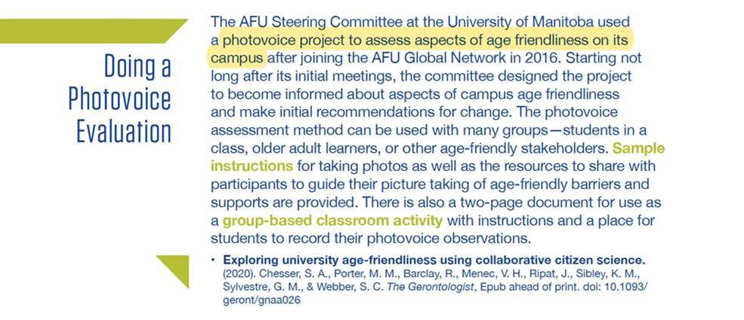
Harleah G. Buck, PhD, RN, FPCN, FAHA, FAAN
Sally Mathis Hartwig Professor in Gerontological Nursing
Co-Director of the Csomay Center for Gerontological Excellence
University of Iowa College of Nursing
50 Newton Road, Iowa City, IA 52242-1121
319-467-1525
harleah-buck@uiowa.edu
ORCID iD https://orcid.org/0000-0003-3226-6607

